Lecture 8
CO1: Apply the knowledge about the concepts of probability and statistics for the computer applications.
CO3: Apply the knowledge about basic ideas of statistics including measures of central tendency, correlation and regression.
Kurtosis

CONCEPT OF KURTOSIS
If we have the knowledge of the measures of central tendency, dispersion and skewness, even then we cannot get a complete idea of a distribution. In addition to these measures, we need to know another measure to get the complete idea about the shape of the distribution which can be studied with the help of Kurtosis. Prof. Karl Pearson has called it the “Convexity of a Curve”. Kurtosis gives a measure of flatness of distribution.
The degree of kurtosis of a distribution is measured relative to that of a normal curve. The curves with greater peakedness than the normal curve is called “Leptokurtic”. The curves which are flatter than the normal curve are called “Platykurtic”. The normal curve is called “Mesokurtic.” The Fig.4 describes the three different curves mentioned above:
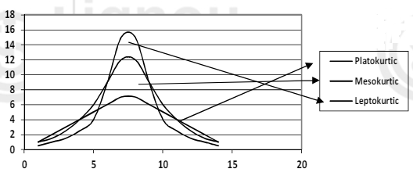
Fig.: Platykurtic Curve, Mesokurtic Curve and Leptokurtic Curve

Measures of Kurtosis
1. Karl Pearson’s Measures of Kurtosis
For calculating the kurtosis, the second and fourth central moments of variable are used. For this, following formula given by Karl Pearson is used:

$$β_{2}=\frac{μ_{4}}{μ_{2}^{2}}$$
$$or {}_{2}=β_{2}-3$$
where, $μ_{2}$= Second order central moment of distribution
$μ_{4}$= Fourth order central moment of distribution

Description:1. If $β_{2}=3 or γ_{2}=0$, then curve is said to be mesokurtic;
2. If $β_{2}<3 or γ_{2}<0$,, then curve is said to be platykurtic;
3. If $β_{2}>3 or γ_{2}>0$,, then curve is said to be leptokurtic.

Example 2: First four moments about mean of a distribution are 0, 2.5, 0.7 and 18.75. Find coefficient of skewness and kurtosis.
Solution: We have $μ_{1}=0, μ_{2}=2.5, μ_{3}=0.7 and μ_{4}=18.75$
Therefore, Skewness $β_{1}=\frac{μ_{3}^{2}}{μ_{2}^{3}}=\frac{{\left(0.7\right)}^{2}}{{\left(2.5\right)}^{3}}=0.031$

$$β_{2}=\frac{μ_{4}}{μ_{2}^{2}}=\frac{18.75}{{\left(2.5\right)}^{2}}=\frac{18.75}{6.25}=3$$

As $β_{2}$ is equal to 3, so the curve is mesokurtic

Practice Question:

- The first four raw moments of a distribution are 2, 136, 320, and 40,000. Find out coefficients of skewness and kurtosis.

TEXT BOOKS
- T1 = H. K Dass, Higher Engineering Mathematics, S. Chand Publishers,3rd revised edition.2014.
- T2 = B.S. Grewal, Higher Engineering Mathematics, Khanna Publishers,42th ed.2013, New Delhi.
- T3= N. P. Bali and Manish Goyal, A textbook of engineering Mathematics, Laxmi Publications, Reprint 2008.

REFERENCE BOOKS
- R1=R. K. Jain and S. R. K. Lyenger, Advanced Engineering Mathematics ,3rd Edition Narosa Publishing House ,2004,New Delhi.
- R2 =B. V. Ramana Advanced Engineering Mathematics, McGrawHill, July2006, New Delhi.
- S.P.Gupta,StatisticalMethods,S.Chand&Sons,2017,NewDelhi,ISBN9789351610281Insiders’Guide

Video Lecture :
https://www.youtube.com/watch?v=TM033GCU-SY&t=65s

